**PIZZA SALES SQL QUERIES**

**A. KPI’s**

**1. Total Revenue:**

SELECT SUM(total_price) AS Total_Revenue FROM pizza_sales;

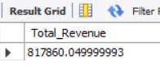

**2. Average Order Value**

SELECT

CAST(SUM(total_price) / COUNT(DISTINCT order_id) AS DECIMAL(10,2))

AS AVG_Order_Value

FROM

pizza_sales;

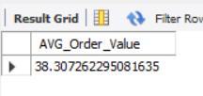

**3. Total Pizzas Sold**

SELECT SUM(quantity) AS Total_Pizza_Sold FROM pizza_sales

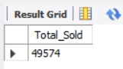

**4. Total Orders**

SELECT COUNT(DISTINCT order_id) AS Total_Orders FROM pizza_sales

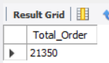

**5. Average Pizzas Per Order**

SELECT

CAST(SUM(quantity) / COUNT(DISTINCT order_id) AS DECIMAL(10,2))

AS AVG_Pizza_Per_Order

FROM

pizza_sales

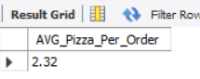

**B. Daily Trend for Total Orders**SELECT

DAYNAME(order_date) AS Order_Day,

COUNT(DISTINCT order_id) AS Order_Count

FROM

pizza_sales

GROUP BY

DAYNAME(order_date)

ORDER BY

Order_Count DESC;

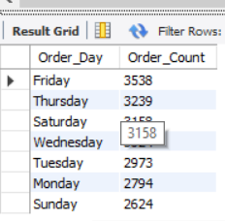

**C. Monthly Trend for Orders**

SELECT

MONTHNAME(order_date) AS Month,

COUNT(DISTINCT order_id) AS Total_Orders

FROM

pizza_sales

GROUP BY

MONTHNAME(order_date)

ORDER BY

COUNT(DISTINCT order_id) DESC;

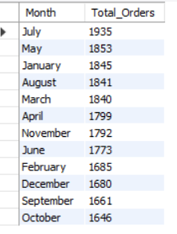

**D. % of Sales by Pizza Category**

SELECT

pizza_category,

CAST(SUM(total_price) AS DECIMAL(10,2)) AS total_revenue,

CAST(SUM(total_price) * 100 / (SELECT SUM(total_price) FROM pizza_sales) AS DECIMAL(10,2)) AS PCT

FROM

pizza_sales

GROUP BY

pizza_category;

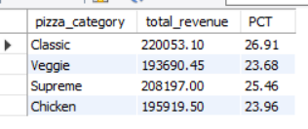

**E. % of Sales by Pizza Size**

SELECT

pizza_size,

CAST(SUM(total_price) AS DECIMAL(10,2)) AS total_revenue,

CAST(SUM(total_price) * 100 / (SELECT SUM(total_price) FROM pizza_sales) AS DECIMAL(10,2)) AS PCT

FROM

pizza_sales

GROUP BY

pizza_size

ORDER BY

pizza_size;

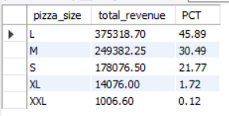

**F. Total Pizzas Sold by Pizza Category**

SELECT

pizza_category,

SUM(quantity) AS Total_Quantity_Sold

FROM

pizza_sales

GROUP BY

pizza_category

ORDER BY

Total_Quantity_Sold DESC;

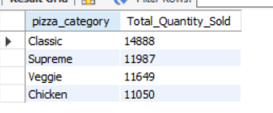

**G. Top 5 Pizzas by Revenue**

SELECT

pizza_name,

SUM(total_price) AS Total_Revenue

FROM

pizza_sales

GROUP BY

pizza_name

ORDER BY

Total_Revenue DESC

LIMIT 5;

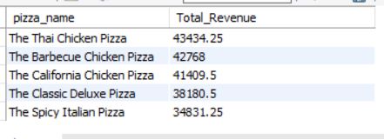

**H. Bottom 5 Pizzas by Revenue**

SELECT

pizza_name,

SUM(total_price) AS Total_Revenue

FROM

pizza_sales

GROUP BY

pizza_name

ORDER BY

Total_Revenue ASC

LIMIT 5;

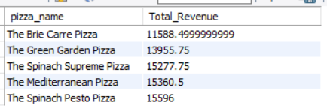

**I. Top 5 Pizzas by Quantity**

SELECT

pizza_name,

SUM(quantity) AS Total_Pizza_Sold

FROM

pizza_sales

GROUP BY

pizza_name

ORDER BY

Total_Pizza_Sold DESC

LIMIT 5;

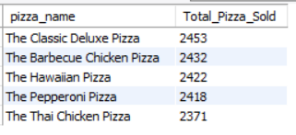

**J. Bottom 5 Pizzas by Quantity**

SELECT

pizza_name,

SUM(quantity) AS Total_Pizza_Sold

FROM

pizza_sales

GROUP BY

pizza_name

ORDER BY

Total_Pizza_Sold ASC

LIMIT 5;

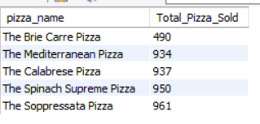

**K. Top 5 Pizzas by Total Orders**

SELECT

pizza_name,

COUNT(DISTINCT order_id) AS Total_Orders

FROM

pizza_sales

GROUP BY

pizza_name

ORDER BY

Total_Orders DESC

LIMIT 5;

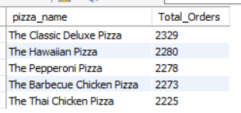

**L. Bottom 5 Pizzas by Total Orders**

SELECT

pizza_name,

COUNT(DISTINCT order_id) AS Total_Orders

FROM

pizza_sales

GROUP BY

pizza_name

ORDER BY

Total_Orders ASC

LIMIT 5;

